

ANXIETY EXPLORED
,
EXPLAINED,

AND REDUCED

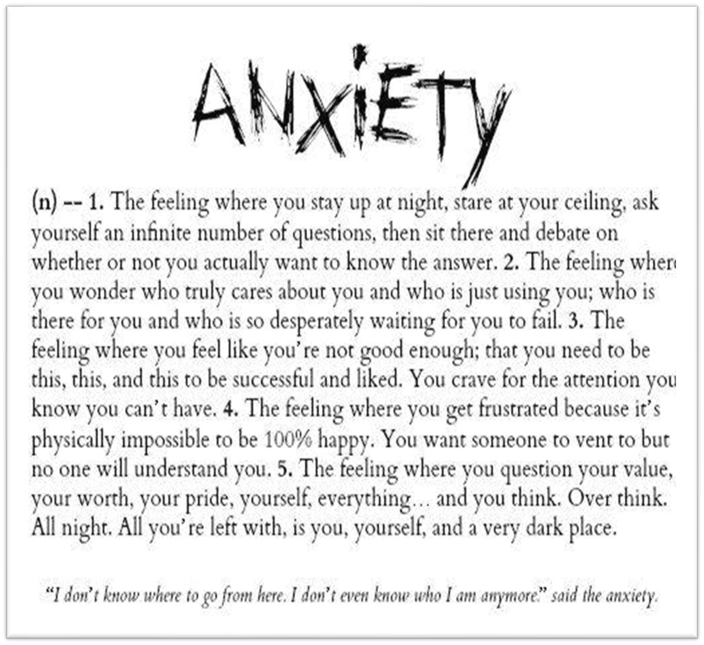

Compiled by: Yvonne Sinclair M.A., LMFT
, CAM1

Masters in Counseling Psychology

Licensed in California

Certified Anger Management Specialist

Certified Domestic
Violence Specialist

22
Years Experience Helping Clients with Anxiety

Anxiety Explained    Anxiety self-assessment  This is a resource to help you understand your level of anxiety  https://landing.google.com/screener/anxiety?source=google  Usually self-diagnosable  Symptoms include stress that's out of proportion to the impact of the event, inability to set aside a worry, and restlessness.  People may experience:  Behavioral: hypervigilance, irritability, or restlessness  Cognitive: lack of concentration, racing thoughts, or unwanted thoughts  Whole body: fatigue or sweating  Also common: anxiety, excessive worry, fear, feeling of impending doom, insomnia, nausea, palpitations, or trembling  A mental health disorder characterized by feelings of worry, anxiety, or fear that are strong enough to interfere with one's daily activities  Examples of anxiety disorders include panic attacks, obsessive-compulsive disorder, and post-traumatic stress disorder.  Symptoms include stress that's out of proportion to the impact of the event, inability to set aside a worry, and restlessness.  Treatment includes counseling or medications, including antidepressants. | Page  2



Helpful LINKS

https://www.rethink.org/advice-and-information/aboutmental-illness/learn-more-about-conditions/anxiety-disorders/

https://www.healthline.com/health/anxietysymptoms#symptoms

https://medlineplus.gov/anxiety.html

ANXIETY RELIEF EXERCISES



As soon as you feel the tightness and/or jittery feelings, do the following to relieve the anxiety symptoms.

- Open up your body.
- Move, stretch, and be physically active.
- Breathe in this way: in through your nose and out through your mouth. Like blowing out a candle.
- Repeat at least two times.
- Monitor you’re “self-talk.”
- Keep what is being said in your head positive: “Been here, done this and I survived. I can calm myself.
- I will be okay, etc.

Now slowly complete the following:
- FIVE-things you can see.

- FOUR-things you can touch

- THREE-things you can hear

- TWO-things you can smell

- ONE-What are you feeling right now? This needs to be an emotional feeling; mad, sad, glad, etc.

Feeling better yet?

Repeat as often as needed…..

*Move,
*Breathe,
*Self-talk,
*5, *4,
*3,
*2, *1.



WHEW-Feelin’ Better?

